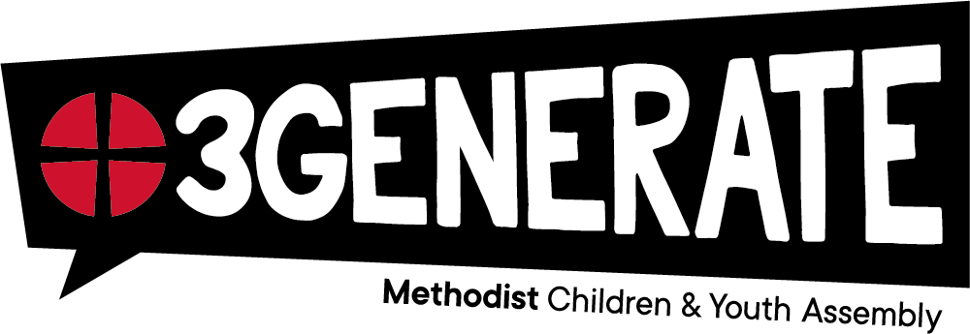
Consent Form
3Generate Event 2026
Date: | 2nd - 4th October 2026 |  |  |  | Venue: | NEC Birmingham
Group Details
Group: |  | Berkshire Hampshire Boarder Circuit |  | Local Church:
Group Leaders: |  | Yvonne Hunt |  | Local Church Contact:
Participant Details
Full Name:
Address: |  |  |  |  |  |  | Post Code:
Date of Birth: |  |  |  |  | Age at event (on 02/10/26): |  |  |  | Sch Yr:
Gender:  Female / Male / Other |  |  | Pronouns:  (Optional) |  | Mobile No.:
Individual Requirements
Any known medical conditions (Physical or Mental Health)
(e.g. diabetic, bipolar etc.)

Details of medication being taken during the event e.g. type of medication – tablets, liquid etc…dosage and when taken, type of inhaler etc.
(NB: epipens and inhalers must be kept with the attendee at all times)

Are there any specific requirements or special needs?
(e.g. hearing/visual impairment, mobility problems, autism, anxiety, understanding or communication issues etc)

Any serious allergies or allergies to medication? (please note allergies such as penicillin, latex or anything that may cause an asthma attack)

Are there any dietary requirements? (including
vegetarian/vegan/pescatarian, gluten free, dairy free, allergies, intolerances or diseases e.g. Coelliac, Crohns, Colitis etc.)

Any additional information?

Emergency Contact Details (please provide two)
First Name: |  |  |  |  | Surname:
Relationship: |  |  |  |  | Mobile number:
Address (if different to attendee):
First Name: |  |  |  |  | Surname:
Relationship: |  |  |  |  | Mobile number:
Address (if different to attendee):
GP Details
Name of GP:
GP address (in the event of an emergency, we may pass on these
details)

Activities
Programme details will be confirmed closer to the event. A variety of activities will be available to participants which include some sporting activities including team sports, exercise machines etc.

Multimedia Images
During the event, attendees may be photographed or recorded (audio or visual) Methodist Church Children, Youth and Family staff take steps to ensure that these images are used solely for the purposes that they are intended, which is the celebration and promotion of the Methodist Church’s work with children and young people. If you become aware that these images are being used inappropriately, you should inform an official as soon as possible. The Methodist Church takes the issue of child safety very seriously and we believe we have a duty of care. This means that images of children and young people will not include names and identifying information.

Young Person’s Declaration (for those 12 and over)
I agree/do not agree* that photographs and/or video can be taken of me for the following purposes:


sharing photographs on a church controlled social media site

newsletters, noticeboards and updates to people in the Methodist Church

I agree to think carefully about how others may feel about images, before I post them on social media. I understand that sometimes I may be asked not to take images or post updates by the group leaders.

Signature: Date:

Parent/Carer Declaration
- I understand the participant (named overleaf) will be under the care of the group leader(s) (named overleaf) throughout the trip and give my consent for the participant to take part in 3Generate (including all activities), as part of this group.

- I confirm that all the information required by the leaders of the group has been provided on this form or separately (e.g. allergies and dietary requirements).

- I confirm that any medication required by the participant will be labelled with their name. I understand that Epipens and inhalers will be kept with the participant at all times. Other medication, e.g. antibiotics, will be in a clear, sealable, plastic bag labelled with the participant’s name.

- I understand that the leaders of this group will be responsible for under-18s’ medication.

- In the event of an emergency, I give my consent to any medical or dental treatment (including an anaesthetic) that may be considered necessary by the medical authorities present.

(please delete as appropriate)
- I give my consent / No I do NOT give my consent to this participant being
photographed and recorded, and for the images used as stated above. The responsibility for this will be with leaders of groups and, where appropriate, the young people themselves. 3Generate will provide “fun” badges such as a smiley face, which participants can choose to wear if they should not be in photos.

Print name:

Signature:

Date:

Relationship to Participant:

This form will be retained by the Group Leaders for the purposes of 3Generate 2026
BHB Circuit:
Please return your completed form to either
your Local Church contact or email it to Yvonne Hunt: Yvonne.h@BHBcircuit.co.uk with 3Generate in the subject area
All forms to be completed and handed in by 19th July 2026

If you have any question, please contact Yvonne Hunt 07462040644

